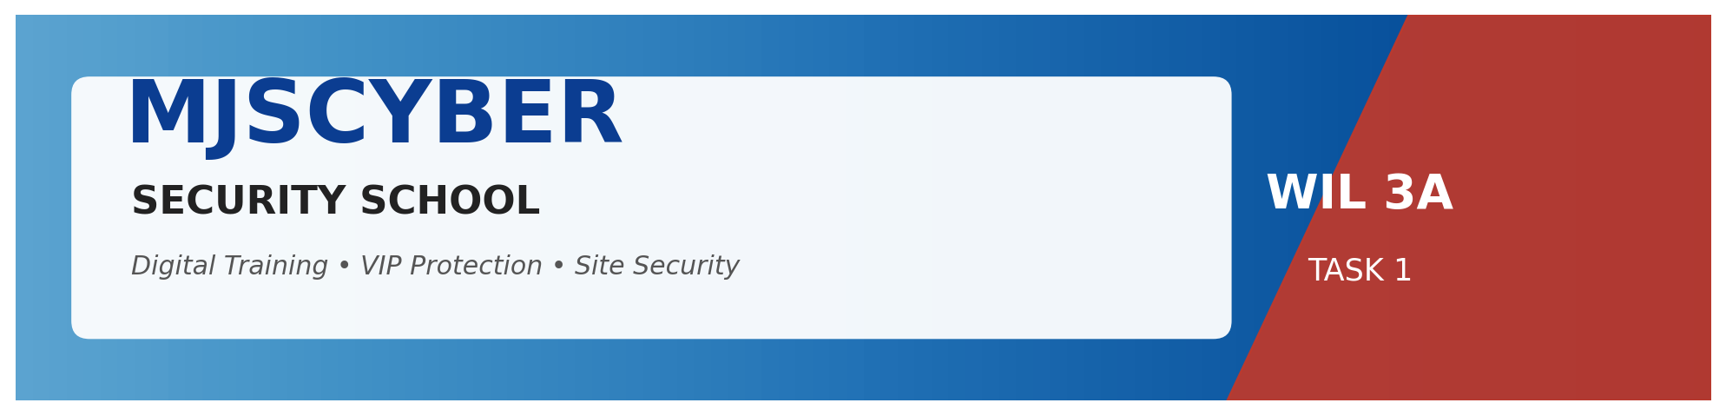

WIL – WORK INTEGRATED LEARNING 3A | Module XISD5319

TASK 2
DESIGN DOCUMENT
MJSCYBER Security School Web Application — System & Technical Design



Client | MJSCYBER PTY LTD (Reg: 2022/201980/07)
Prepared By | Jones Sepuru & Khumela Sendelani
Client Location | Bochum, Limpopo, South Africa
Submission Date | 22 April 2026
Document Version | 1.0 – Final

Group Members
Student Name | Jones Sepuru
Student Number | [Insert Student Number]
Student Name | Khumela Sendelani
Student Number | [Insert Student Number]

Table of Contents
1. | Introduction | 3
2. | System Architecture | 4
3. | Use-Case Modelling | 5
4. | Data Model & Entity Relationship Diagram | 6
5. | Data Dictionary | 7
6. | User Interface Design | 9
7. | API Specification | 10
8. | Security Design | 12
9. | Non-Functional Requirements | 13
10. | Technology Stack & Justification | 14
11. | Design Assumptions & Constraints | 15
12. | Conclusion | 16

1. Introduction
This Design Document translates the approved Project Plan (Task 1) into a concrete, implementable technical blueprint for the MJSCYBER Security School Web Application. It specifies system architecture, data models, user interactions, APIs, and security controls — forming the agreed baseline that development (Phase 3) and testing (Phase 4) will be measured against.

1.1 Scope
- Student self-service: registration, enrolment, payment, grading, certificate download.
- Public certificate verification via unique serial and QR code.
- VIP protection and site-security service requests with admin workflow.
- Admin control centre: courses, enrolments, grading, certificate issue, KPIs.

1.2 Design Goals
- Keep the solution lightweight enough to run reliably on limited-bandwidth rural connections.
- Enforce tamper-proof digital records aligned to POPIA and PSiRA compliance.
- Maintain a clean separation between public, student and admin concerns via role-based access.
- Favour open-source, free-tier tools to keep total cost of ownership within budget.

2. System Architecture
The solution follows a classical 3-tier architecture. A rich single-page React application communicates over HTTPS with a FastAPI service, which in turn persists data to MongoDB and integrates with Stripe for payments. Authentication is achieved via JWT tokens stored as httpOnly cookies — never accessible to JavaScript.
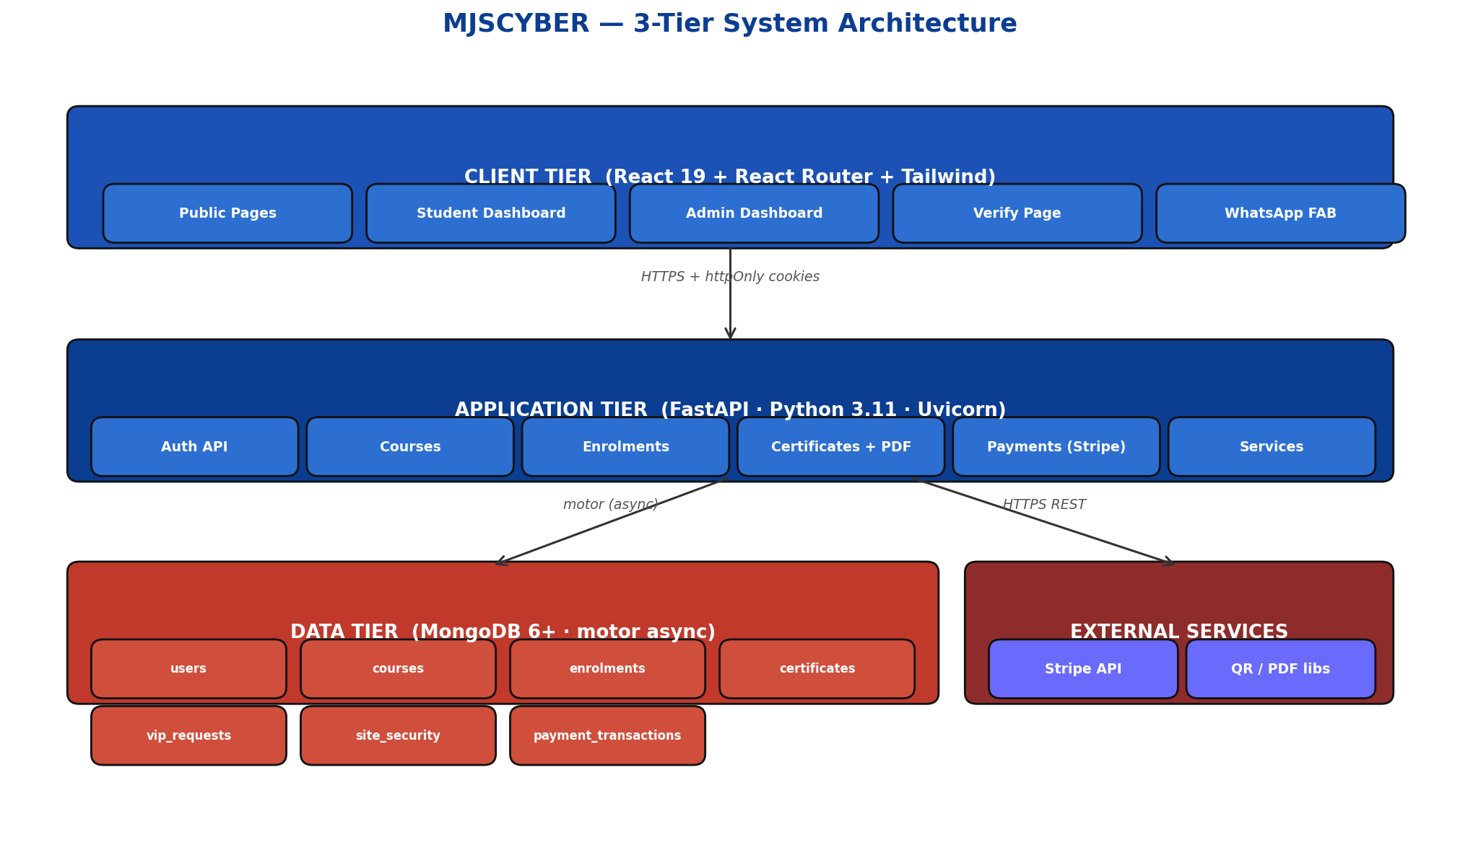
Figure 2.1 – MJSCYBER 3-tier system architecture

2.1 Architectural Principles
- Separation of concerns: presentation (React), business logic (FastAPI), persistence (MongoDB).
- Stateless backend: each request carries its own JWT; enables horizontal scaling.
- All external integrations (Stripe) are invoked from the backend only.
- Frontend consumes ONLY the REACT_APP_BACKEND_URL — no hardcoded hosts.

3. Use-Case Modelling
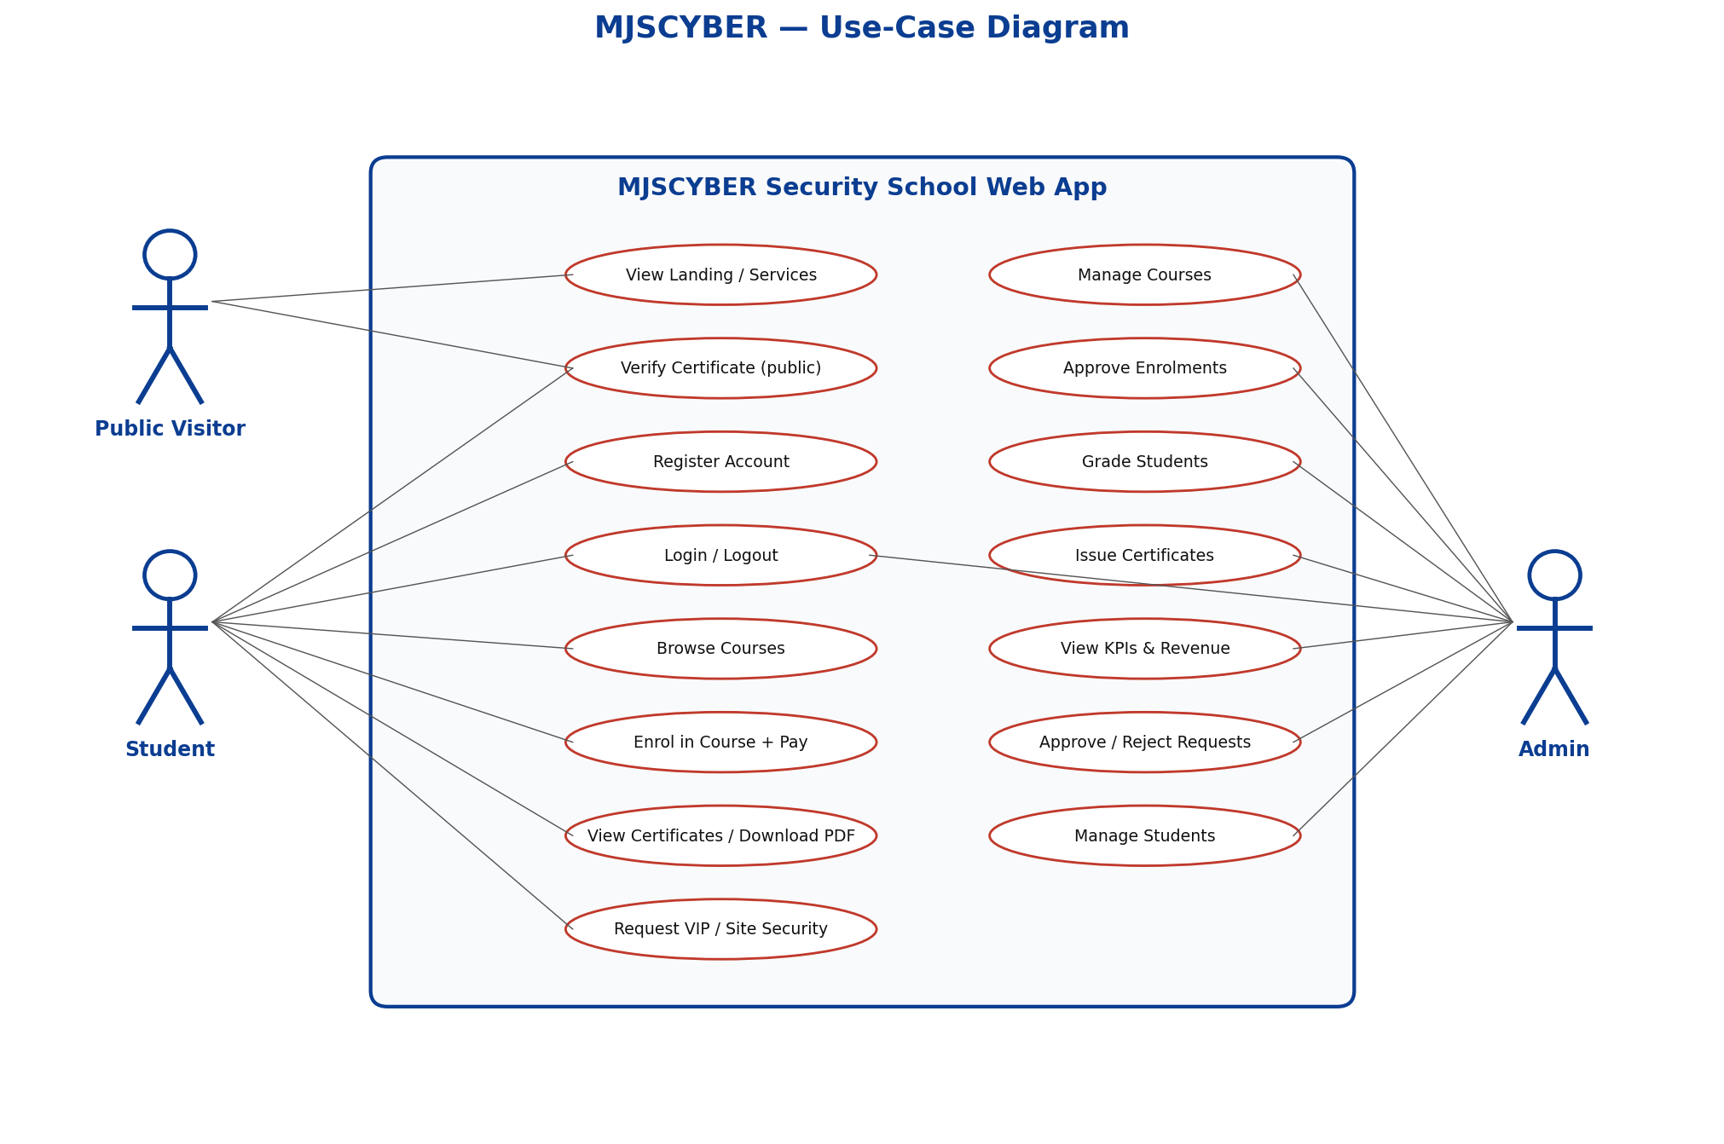
Figure 3.1 – Actor and use-case diagram

3.1 Primary Actor Summary
Actor | Description | Key Use Cases
Public Visitor | Unauthenticated user browsing the site | View landing, verify a certificate, register
Student | Authenticated learner, role=student | Enrol in course, pay tuition, take theory/practical, view certificates, request VIP / site service
Admin | MJSCYBER staff, role=admin | Manage courses, approve enrolments, grade, issue certificates, review service requests, view KPIs
Table 3.1 – Actor responsibilities

4. Data Model & Entity Relationship Diagram
MongoDB is a document database, but entity relationships are enforced at the application layer via ObjectId references. The diagram below shows each collection and its relationships.
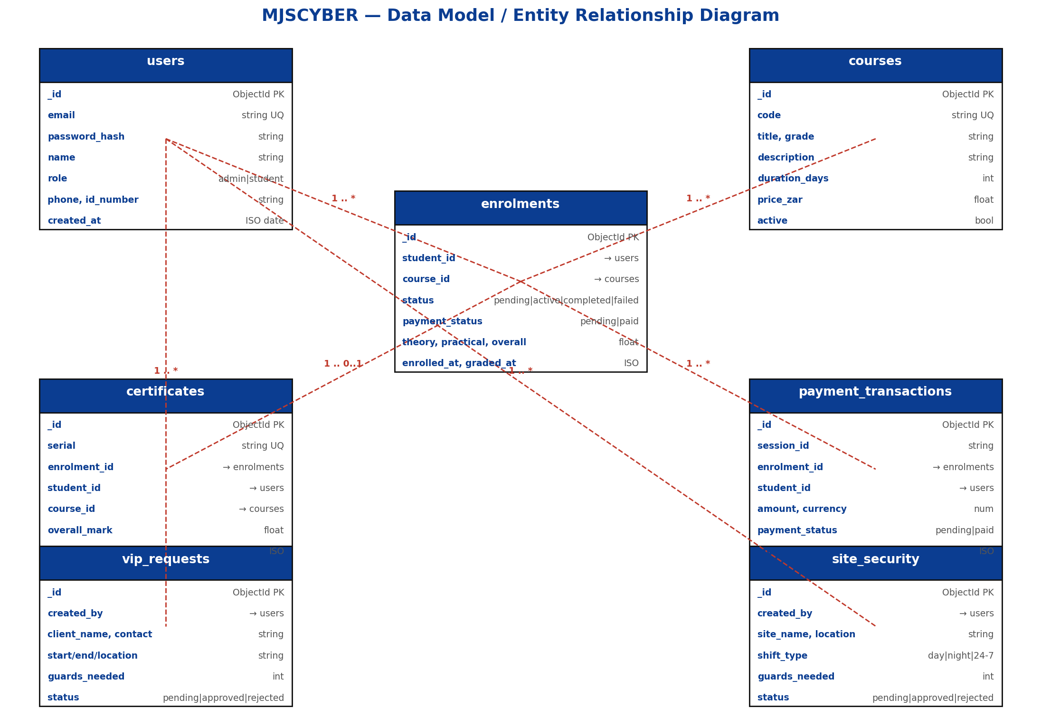
Figure 4.1 – MJSCYBER data model

5. Data Dictionary

5.1 users
Field | Type | Constraints | Notes
_id | ObjectId | PK | Mongo primary key
email | string | unique, lower | Used for login
password_hash | string | bcrypt 12-round | Never returned to client
name | string | required | Full name
role | enum | admin | student | RBAC
phone | string | optional
id_number | string | optional | SA ID, 13 digits
created_at | ISO datetime | required

5.2 courses
Field | Type | Constraints | Notes
_id | ObjectId | PK
code | string | unique | e.g., PSE-E, AR-01
title | string | required
grade | string | required | E,D,C,B,A,SP
description | string | required
duration_days | int | >=1
price_zar | float | >=0 | Tuition in ZAR
active | bool | default true | Soft-archive flag

5.3 enrolments
Field | Type | Constraints | Notes
_id | ObjectId | PK
student_id | string | FK users
course_id | string | FK courses
status | enum | pending|active|completed|failed
payment_status | enum | pending|paid
theory_mark | float | 0-100 or null
practical_mark | float | 0-100 or null
overall_mark | float | computed avg
enrolled_at | ISO | required
graded_at | ISO | optional

5.4 certificates
Field | Type | Notes
serial | string (UQ) | MJS-YYYY-XXXXXXXX
enrolment_id | FK
student_id / name / email / id_number | denormalised | For tamper-proof snapshot
course_title / code / grade | denormalised | Snapshot at time of issue
overall_mark | float
issued_at | ISO
issuer | string | MJSCYBER PTY LTD
valid | bool | Soft-revocation flag

5.5 payment_transactions, vip_requests, site_security
See the ERD (Figure 4.1). These collections are referenced from the application layer by string-cast ObjectId. Each carries a status machine (pending → paid/approved/rejected) and is filtered by created_by for students, unrestricted for admin.

6. User Interface Design
The UI adopts a modern dark theme (navy + red accents) to reflect the professional security industry. All pages are responsive and tested on 1440-wide and mobile viewports.
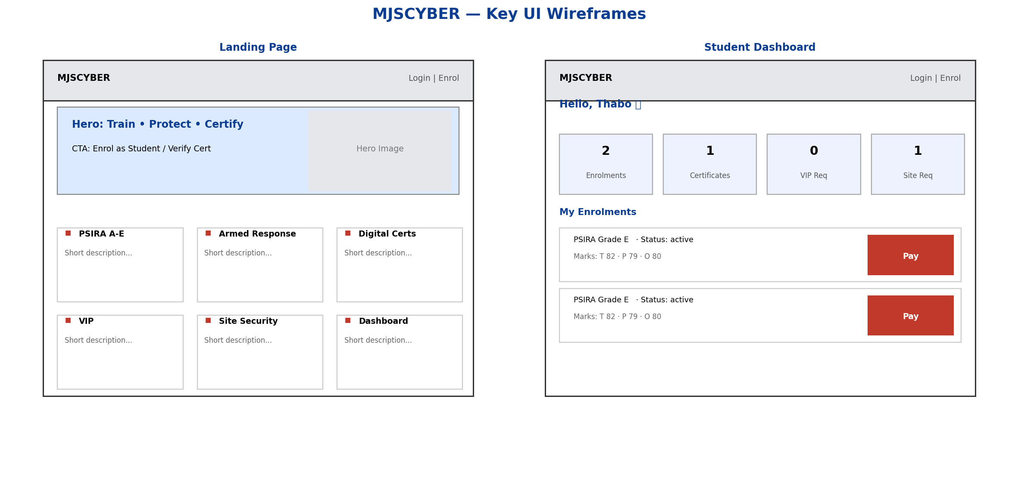
Figure 6.1 – Key-page wireframes: Landing and Student Dashboard

6.1 Screen Inventory
Route | Purpose | Access
/ | Landing: hero, features, journey, CTA | Public
/about | Mission, vision, values, timeline, services, contact | Public
/courses | Course catalogue; enrol button when student | Public
/verify/:serial | Public certificate authenticity check | Public
/login, /register | Authentication forms | Public
/dashboard | Student: enrolments, certs, service requests, Pay | Student
/admin | 7-tab admin control centre | Admin

6.2 Design System
- Primary: #0B3D91 (navy). Accent: #C0392B (red). Background: #07080C (near-black).
- Typography: Calibri (print) / Barlow-Inter (web); tight 1.05 leading for hero titles.
- Components: card, card-glass, btn-primary / accent / outline / ghost, badges (blue, green, amber, red, zinc).
- Micro-interactions: fade-up entrance on hero, pulse dot on status indicators, hover scale on CTAs.

7. API Specification
All routes prefixed with /api. Authentication uses httpOnly cookies — frontend passes withCredentials: true. Error responses follow RFC 7807 structure {detail: <string|list>}.

7.1 Authentication
Method & Path | Body | Response
POST /api/auth/register | {email, password, name, phone?, id_number?} | User object; cookies set
POST /api/auth/login | {email, password} | User object; cookies set
POST /api/auth/logout | — | {ok:true}; cookies cleared
GET /api/auth/me | — | Current user
POST /api/auth/refresh | — | New access cookie

7.2 Courses
Method & Path | Role | Notes
GET /api/courses | Public | Active courses only
GET /api/courses/all | Admin | Includes archived
POST /api/courses | Admin | Create course
PUT /api/courses/{id} | Admin | Update/archive
DELETE /api/courses/{id} | Admin | Soft-archive

7.3 Enrolments, Certificates, Services, Payments
Method & Path | Role | Purpose
POST /api/enrolments | Student | Enrol in a course (pending)
GET /api/enrolments/mine | Student | List own enrolments
GET /api/enrolments | Admin | All enrolments
PATCH /api/enrolments/{id}/approve | Admin | Move pending → active
PATCH /api/enrolments/{id}/grade | Admin | Record marks, auto status
POST /api/certificates/issue/{eid} | Admin | Issue cert for completed enrol
GET /api/certificates/{id}/pdf | Owner/Admin | Download branded PDF
GET /api/verify/{serial} | Public | Public cert verification
POST /api/vip-requests | Any auth | Create VIP request
POST /api/site-security | Any auth | Create site request
POST /api/payments/checkout | Student | Create Stripe session
GET /api/payments/status/{sid} | Student | Poll payment status
POST /api/webhook/stripe | Stripe | Webhook handler
GET /api/admin/stats | Admin | KPI summary

8. Security Design

Figure 8.1 – Layered security: at rest, in transit and at access
Control | Implementation
Password storage | bcrypt (12 rounds) via passlib; never stored plain
Session tokens | JWT in httpOnly, SameSite=Lax cookies; JS cannot read them
Token lifespan | Access 12 h · Refresh 7 d; refresh rotates on use
Brute force | 5 failed login attempts / 15-min lockout per IP:email
Role-based access | FastAPI dependency get_current_user + require_admin
Transport | HTTPS end-to-end (TLS 1.2+)
Payment tampering | Amount computed server-side from course.price_zar, not client input
POPIA / PII | ID numbers stored and only exposed to admin; never in public JSON
CORS | Restricted to FRONTEND_URL in production
SQL / NoSQL injection | Parameterised queries; ObjectId validated; no string concat
Table 8.1 – Security control matrix

9. Non-Functional Requirements
Attribute | Target
Availability | ≥ 99 % during business hours (Mon-Sat 07:00–19:00 SAST)
Response time | P95 < 400 ms on all authenticated endpoints under 100 RPS
Certificate issue | Complete round-trip < 2 s including PDF generation
Capacity | Supports 5 000 students, 20 000 enrolments, 50 000 certificates without redesign
Scalability | Stateless backend; horizontally scalable behind a load balancer
Accessibility | WCAG 2.1 AA contrast on all text; keyboard-navigable forms
Browser support | Chrome / Edge / Firefox / Safari — last 2 major versions
Mobile | Fully responsive from 320 px upward
Backup | MongoDB daily snapshot, 14-day retention
Audit | Every admin mutation logged with timestamp + actor id

10. Technology Stack & Justification
Layer | Choice | Why
Frontend | React 19 + React Router 7 + Tailwind CSS | Mature ecosystem, component reuse, first-class DX, easily hostable as static files.
Backend | FastAPI (Python 3.11) + Uvicorn | Async out of the box, auto OpenAPI docs, strong Pydantic validation.
Database | MongoDB 6 + motor (async driver) | Flexible schema for evolving business rules; free-tier cloud hosting via Atlas.
Auth | PyJWT + bcrypt | Widely audited; cookie-based pattern matches SPA use.
Payments | Stripe Checkout (test mode) | Industry standard; ZAR supported; no card data ever touches our servers.
PDF | ReportLab + qrcode | Server-side PDF with QR code; open source.
Hosting plan | Afrihost cPanel (Python+Node) or Emergent | Local SA hosting, low latency to Limpopo; affordable.
DevOps | GitHub + GitHub Actions (deferred) | Source control + CI/CD ready for a follow-up sprint.

11. Design Assumptions & Constraints
- Certificates are ONLY issued for enrolments whose overall mark ≥ 50 %.
- Students may hold multiple enrolments but only one active enrolment per course at a time.
- Service request status machine: pending → (approved | rejected); no resubmission on rejection (must create a new request).
- All monetary values are in South African Rand (ZAR).
- Email notifications are deferred to a follow-up iteration; client approval captured in meeting minutes dated 22 April 2026.
- Prices are stored on the course document; historical price at time of enrolment is captured on the payment_transactions record for auditing.

12. Conclusion
This Design Document provides the technical backbone needed to implement the MJSCYBER Security School Web App to the agreed scope, budget and timeline. The architecture is deliberately simple and production-ready, built on mature, well-supported open-source technologies. The next step (Task 3) demonstrates that the implementation faithfully realises this design.

